**2 FMCW Radar**

**2.1 Composition of FMCW radar system**

The composition of FMCW radar system mainly includes: sawtooth wave signal generator, transceiver module, digital-to-analog converter, digital signal processor and controller. The signal is generated by the sawtooth wave signal generator, passed through the frequency multiplier and the power amplifier in turn, and transmitted by the transmitting antenna. The electromagnetic wave is reflected by the object and received by the receiving antenna. The received signal is mixed with the transmitted signal after passing through a low-noise amplifier to obtain an intermediate frequency signal. Finally, the intermediate frequency signal is filtered and ADC sampled sequentially, and then input to the back end for further signal processing. The block diagram of a typical FMCW radar system is shown in Figure 2.1.

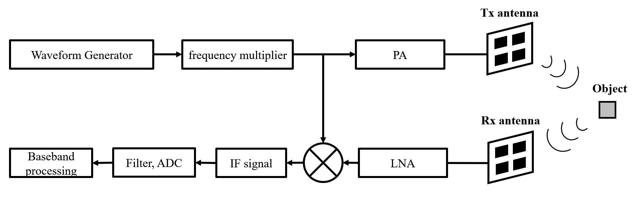

Fig. 2.1. Block diagram of a typical FMCW radar system

**2.2 Analysis of FMCW Radar IF Signal**

For FMCW radar, a variety of modulations is possible. The transmitter frequency can slew up and down as follows: Sine wave, Sawtooth wave, Triangle wave, Square wave, etc.

Sawtooth modulation is the most used in FMCW radars, so the following analysis is based on the sawtooth wave.

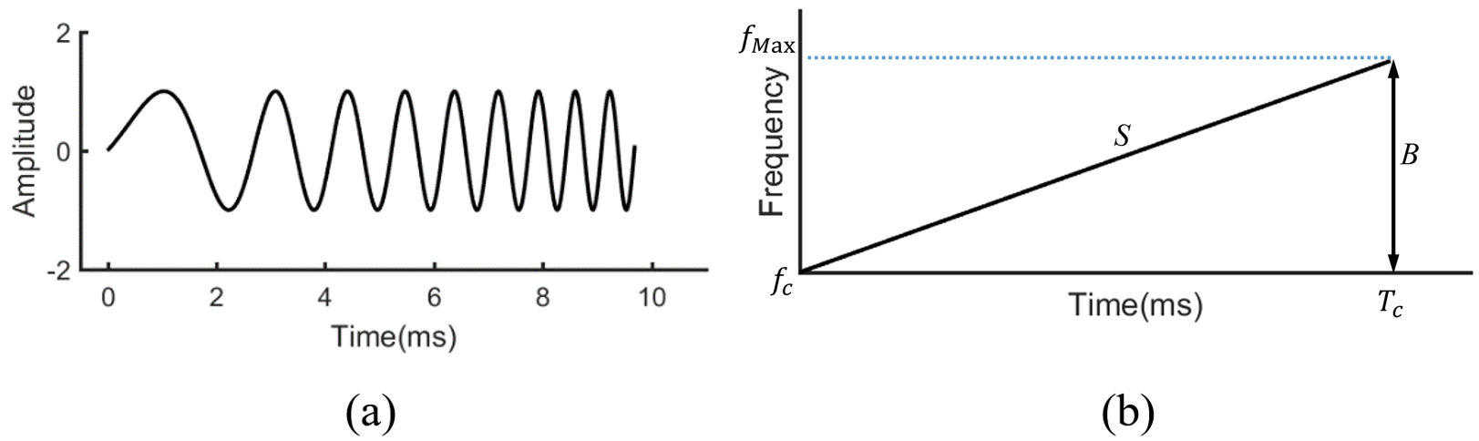

Fig. 2.2. Block diagram of a typical FMCW radar system

The sawtooth wave of FMCW radar is a frequency linear modulation method. The frequency of electromagnetic waves changes linearly with time. The schematic diagram is shown in Figure 2.2. Figure 2.2 (a) shows the time domain representation. The transmitted signal in a cycle is usually called a chirp. Figure 2.2 (b) shows the frequency-time diagram of a chirp.

Denote as the chirp repetition period, is the bandwidth of the chirp, . The mathematical expression for the transmitted signal within one frequency ramp interval is:

|  |  |  |
| --- | --- | --- |
|  |  |  |

where is the center frequency of the frequency ramp, is the initial phase residual, . Suppose that there is a reflection point, and its distance from the radar as a function of time is . Assuming that the movement of the scattering point is relatively slow, thus can be regarded as a constant within a certain period. This is a "stop-and-go" hypothesis, which is extremely common when dealing with slow moving targets. Therefore, for the scattering point located at , the echo signal received by the FMCW radar is a function of the time delay and a certain amplitude attenuation of the transmitted signal. Among them, the time delay is:

|  |  |  |
| --- | --- | --- |
|  |  |  |

Therefore, the echo signal can be expressed as:

According to Figure 2-1, the received signal is mixed with the transmitted signal. After that, the resulting mixed signal is low-pass filtered and the intermediate frequency signal is obtained:

|  |  |  |
| --- | --- | --- |
|  |  |  |

It can be seen from equation (2-4) that the obtained intermediate frequency signal is a sinusoidal motion with frequency :

|  |  |  |
| --- | --- | --- |
|  |  |  |

**2.3 FMCW radar parameter estimation**

Based on the intermediate frequency signal obtained in Section 2.2, parameters such as the position, velocity, and angle of the target object can be estimated. The parameter estimation and parameter resolution are discussed separately below.

2.3.1 FMCW radar range estimation

Since the frequency of the electromagnetic wave emitted by the FMCW radar system changes linearly with time, the frequency of the received electromagnetic wave also changes linearly with time. Therefore, when the frequency of the IF signal obtained by mixing the transceiver signals is determined, the distance of the object can be obtained according to the known slope S of the sawtooth wave modulation.

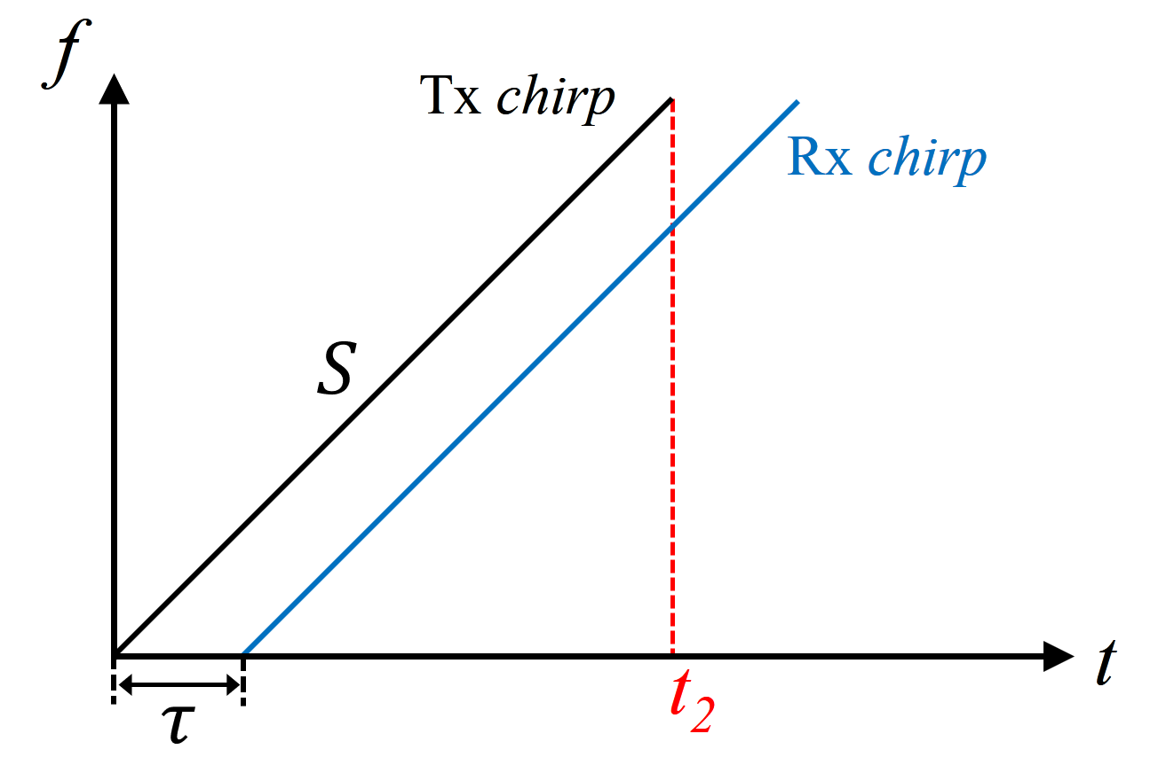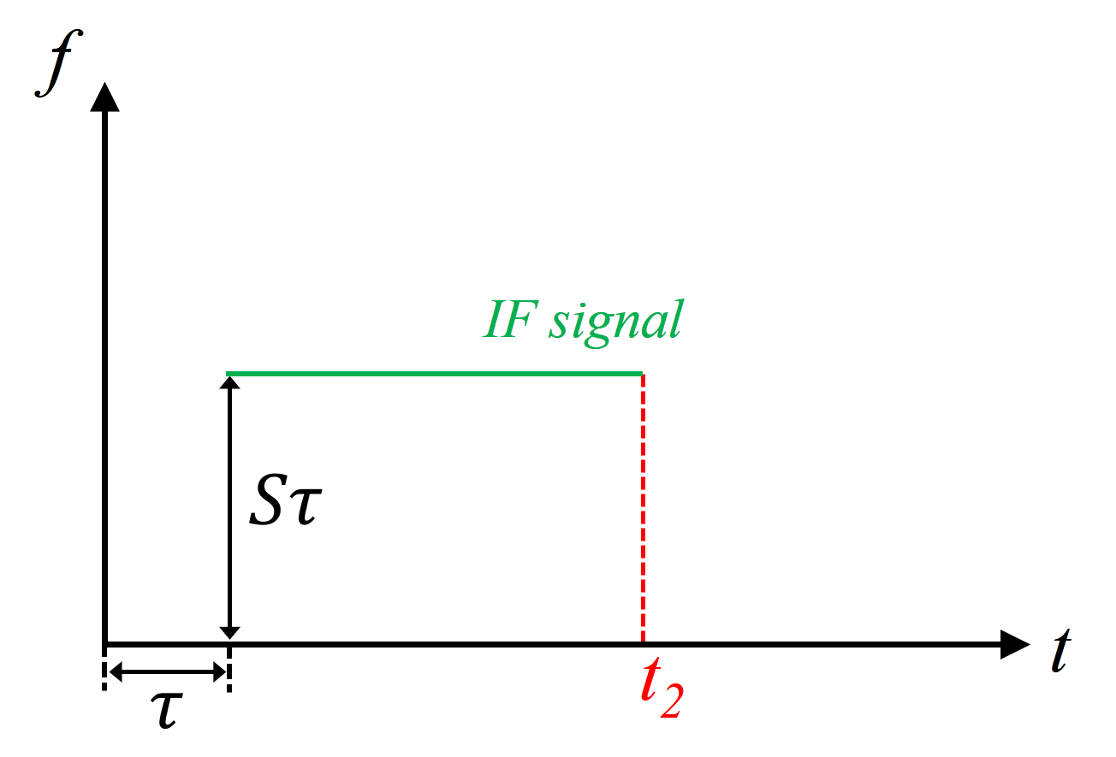

(a) (b)

Fig. 2.3. FMCW intermediate frequency signal diagram

As shown in Figure 2.3, the transmitted signal is received by the radar after time . Therefore, the transmitted Tx chirp and the received Rx chirp are two parallel lines with the same slope on the frequency-time graph. Note that the slope of the transmitted sawtooth wave is S, and the duration of the transmitted signal is . The frequency-time diagram of the IF signal is shown in Figure 2.3 (b). The frequency of the intermediate frequency signal .

Therefore, when there is a single object in front of the radar, the frequency-time diagram of the generated intermediate frequency signal is a single-valued line, and the frequency is proportional to the EM wave propagation time. From formula (2-2), we know that the propagation time is proportional to the distance from the object to the radar, that is , where *d* is the distance from the object to the radar.

In summary, the distance from the object to the radar can be obtained from the frequency of the intermediate frequency signal obtained in equation (2-4):

|  |  |  |
| --- | --- | --- |
|  |  |  |

It should be noted that when using ADC for sampling, the time-point of interest must be within the time window of [, ].

Similarly, when there are multiple objects in front of the radar, the reflected wave is similar to the single one. As shown in Figure 2.4, there are three objects in front of the radar. Three reflected signals are generated, namely Rx chirp 1, 2, 3. From the time when the last reflected wave signal Rx chirp 3 is received to the end of the transmitted signal Tx chirp, the fast Fourier transform is performed on the intermediate frequency signal, and three peaks can be obtained. Each peak corresponds to a target object, and the higher peak indicates that the object is farther away from the radar. This process is called Range-Fourier Transform (Range-FFT).

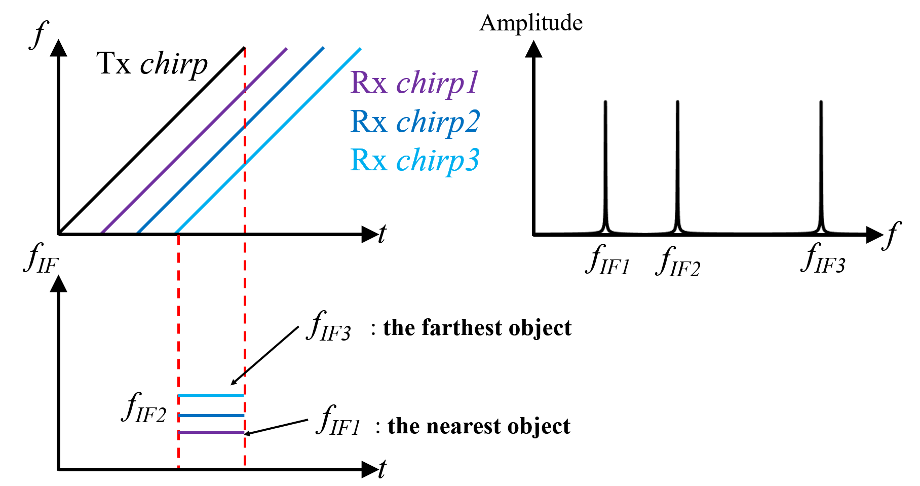

Fig. 2.4. FMCW radar multi-target range estimation

The right figure in Figure 2.4 is the result of the Range-FFT of the intermediate frequency signal. It can be seen from the spectrum image that its three peaks correspond to the three intermediate frequency signals in the frequency-time diagram on the left, and the distance between the three targets and the radar can be obtained according to equation (2-6).

2.3.2 FMCW radar velocity estimation

From the analysis in Section 2.3.1, it can be seen that the distance information of the target can be obtained by performing a fast Fourier transform on the intermediate frequency signal after using the transmitted signal Tx chirp once. It is not difficult to think of launching two chirps to get the distance that the object moves between the two launches, so as to calculate the speed of the object.

However, when an object moves at a very small distance, the frequency of IF signal is very insensitive to small movements. As demonstrated here, suppose that there is a FMCW radar that emits a sawtooth wave, the operating frequency is 77GHz, its operating wavelength , bandwidth , sawtooth wave repetition period , the slope of the sawtooth wave . When the object moves 1mm within two sawtooth wave cycles, that is, , the frequency change amount of the IF signal is:

|  |  |  |
| --- | --- | --- |
|  |  |  |

It can be seen that the frequency change of the IF signal is only 333Hz, which is less than 0.1% compared with the operating frequency of 77GHz. At the same time, the analysis in the latter section shows that , so the value of cannot be obtained using distance measurement.

The FMCW radar speed estimation requires the use of multiple periods of Tx chirp. By extracting the changes of the phase information of multiple chirps, the displacement of the object within the two sawtooth wave periods is obtained, and then the estimation of the object's velocity is completed.

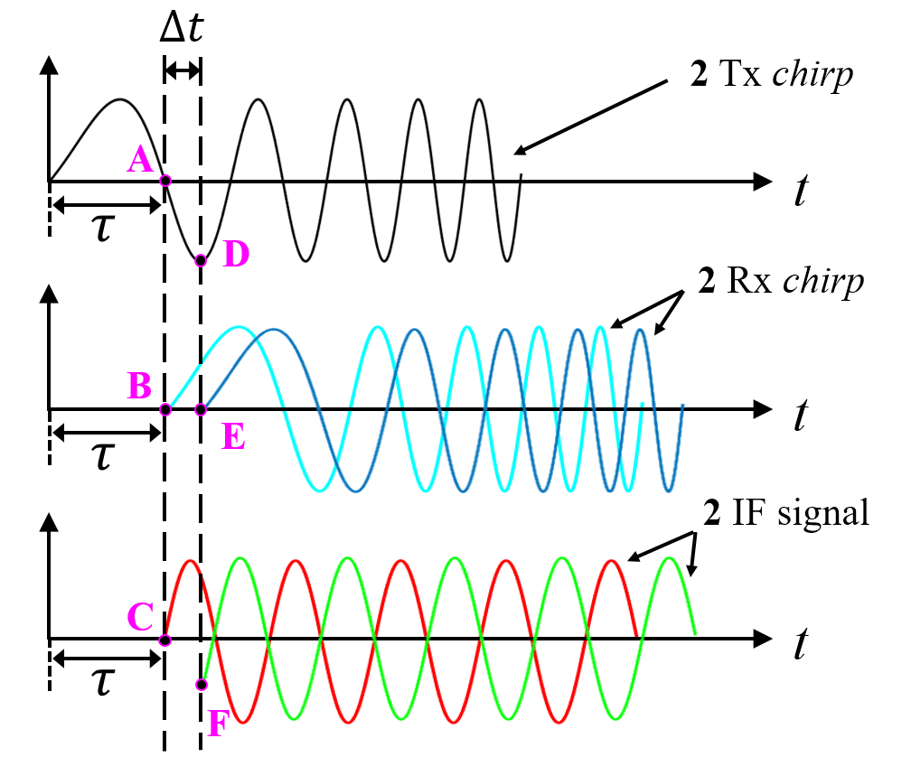

Fig. 2.5. Phase analysis of FMCW radar IF signal

The first step is the phase analysis of the FMCW radar IF signal. The top graph in Figure 2.5 is the time-domain waveform of the transmitted signal. Assuming that two chirps are continuously transmitted, the repetitive time of the transmitted signal waveform is . Since the repetitive time is generally in the μs level, which is very small relative to the time axis, the image of the two consecutive transmitted signal waveforms on the time axis can be considered overlapping. That is, the top image is actually a superimposed image of two transmitted waveforms with very short intervals on the time axis.

Suppose the first Tx chirp emitted returns after time τ, forming the light blue waveform in the middle image in Figure 2.5, and the second Tx chirp returns after time as a dark blue waveform. The delay is caused by a slight displacement of the object within two repetitive periods of emitted Tx signal waves. It should be noted that and are also very small amounts of time, so they are enlarged for display here.

The bottom figure of Figure 2.5 is the IF signal formed by the two received signals and the transmitted signal respectively. By analyzing the phases of the two IF signals, the moving distance of the object during time can be obtained.

It can be obtained from Figure 2.5 that the phase difference between point A and point D is . At the same time, we get the relationship in the waveform: point B and point E are 0 phase, the phase of point C is the negative value of phase A; the phase of point F is the negative value of phase D. Therefore, the phase difference between point A and point D is also the phase difference between point C and point F.

According to the conclusion in section 2.2, the expression of sinusoidal IF signal can be rewritten as follows:

where is the frequency of the signal, c is the speed of light.

When there are two IF signals, the phase difference is:

note, then the velocity estimation is:

Taking the example that have mentioned before. For a FMCW radar operating at 77 GHz, the phase change . It can be concluded that the frequency is almost negligible for small movement changes, but the phase information is very sensitive to small distance changes. Therefore, the phase information is used to complete the velocity estimation with higher resolution.

It should be noted that because the speed is detected using changes in phase information, it must be effective within the range of , which limits the maximum upper limit of speed estimation :

|  |  |  |
| --- | --- | --- |
|  |  |  |

In addition, the direction of the object's movement relative to the radar can be distinguished by the sign of :

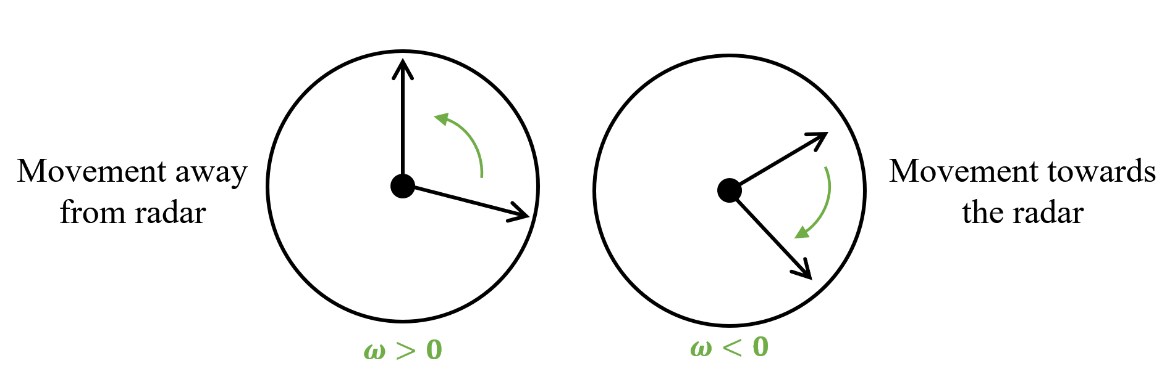

Fig. 2.6. Relationship between phase sign and object movement direction

As shown in Figure 2.6, when , the object moves in the direction away from the radar. When , the object moves in the direction of approaching the radar.

2.3.3 FMCW radar angle estimation

The angle estimation of the FMCW radar requires at least two receiving antennas. The schematic diagram is shown in Figure 2.7.

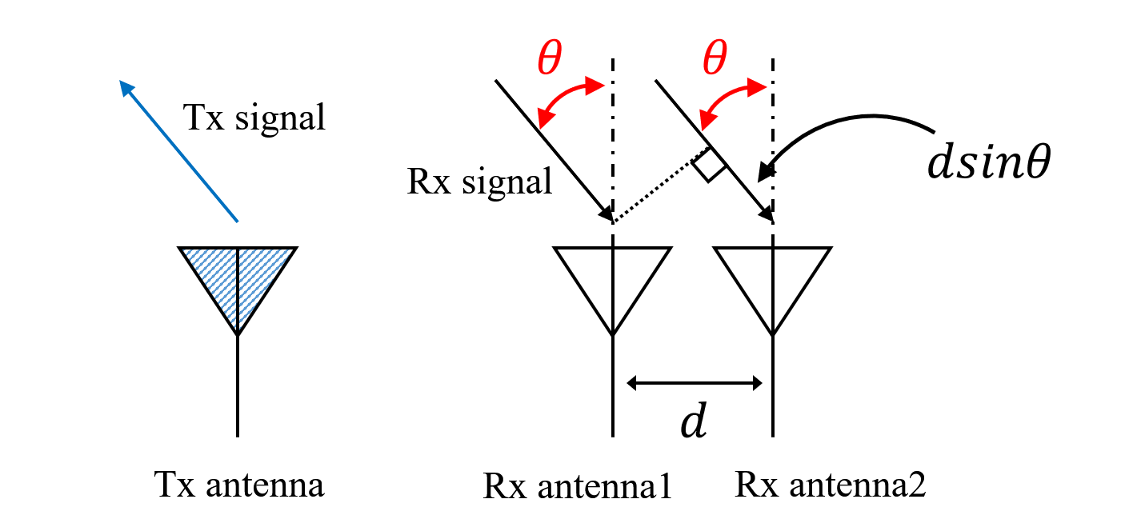

Fig. 2.7. Schematic diagram of FMCW radar angle estimation

Assuming that the distance between the two receiving antennas is *d*, since *d* is relatively small compared to the distance from the object to the radar, the reflected signals reaching the two receiving antennas can be regarded as parallel incidence. Assuming the normal angle between the object and the receiving antenna is , the reflected signals received by the receiving antennas 1 and 2 have a wave path difference . Therefore, the phase difference of the reflected signals received by the two receiving antennas contains the angle information of the target.

The phase difference between Rx antennas can be expressed as:

|  |  |  |
| --- | --- | --- |
|  |  |  |

Inversely transform equation (2-13) to obtain the angle information of the target:

|  |  |  |
| --- | --- | --- |
|  |  |  |

It should be noted that for equation (2-14), this is the first time that nonlinearity occurs in FMCW radar parameter estimation. The non-linearity of the arc sine function makes the sensitivity differs at different angles.

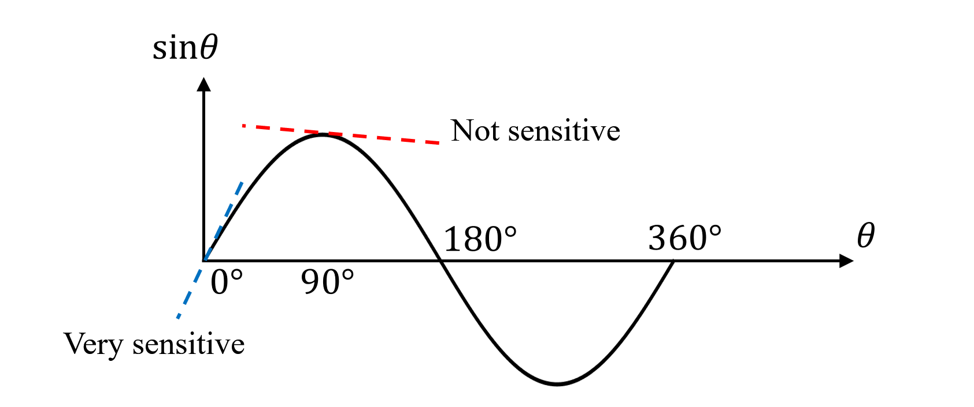

Fig. 2.8. FMCW radar angle estimation sensitivity with angle

As shown in Figure 2.8, when the angle close to 0°, since the slope of the sine function is large, the change of the arc sine function to the angle is obvious, but when it reaches 90°, the slope of the sine function gradually approaches 0, therefore, the accuracy of angle estimation decreases rapidly. That is, when the object is directly in front of the radar, the angle estimation is the most accurate. The closer the target is to the sides of the radar, the worse the angle estimation accuracy will be.

**2.4 FMCW radar parameter estimation resolution**

2.4.1 FMCW radar range estimation resolution

According to formula (2-6), we know the relationship between the estimated distance and the frequency of the intermediate frequency signal: .

When the distance changes by a small value , the frequency change of the corresponding intermediate frequency signal is:

|  |  |  |
| --- | --- | --- |
|  |  |  |

Because the minimum frequency value that can be resolved by the system is limited by the transmission frequency of the transmitted signal, that is:

Take formula (2-16) into formula (2-16) to get the distance resolution:

|  |  |  |
| --- | --- | --- |
|  |  |  |

where B is the bandwidth of the FMCW radar, that is, the minimum resolution of the distance estimation is limited by the frequency sweep bandwidth of the radar.

At the same time, the longest distance estimate can be defined by equation (2-6):

where is the largest IF signal frequency. It can be seen from the block diagram of the FMCW radar system in Figure 2.1 that the obtained intermediate frequency signal is subjected to low-pass filtering and then ADC sampling. From the knowledge of the signal and the system, to make the original signal completely repeated, the sampling rate must be greater than the maximum frequency of the intermediate frequency signal, that is, . Therefore:

where is the sampling frequency of the ADC. It can be seen that the furthest measurable distance is limited by the sampling frequency of the ADC, namely:

|  |  |  |
| --- | --- | --- |
|  |  |  |

In summary, the range resolution of FMCW radar is inversely proportional to the bandwidth. The only way to achieve better range resolution is to increase the bandwidth. The furthest measurable distance is limited by the sampling frequency of the ADC and the slope of the sawtooth wave. If you want to get a longer test distance, you need to increase the sampling frequency of the ADC.

2.4.2 FMCW radar velocity estimation resolution

From equation (2-11), the maximum value of the FMCW radar velocity estimation is limited by the repetition time of the transmitted waveform, namely:

|  |  |  |
| --- | --- | --- |
|  |  |  |

Since, when the speed value changes by , the change value of is:

Since there are N chirps in a group, the premise of resolving the angle is:

Bringing in (2-22), the resolution of the speed can be obtained as:

|  |  |  |
| --- | --- | --- |
|  |  |  |

where is the total transmission duration of a group (N chirps), , and is the repetition time of chirp.

In summary, the velocity resolution of the FMCW radar is inversely proportional to the total duration of a group of transmitted signals. To obtain better speed resolution, the total duration of a group of transmitted signals needs to be reduced. The maximum measurable velocity value is inversely proportional to the repetition time of a single waveform. To increase the maximum measurable velocity of FMCW radar, a faster waveform transmission frequency is required.

2.4.1 FMCW radar angle estimation resolution

According to (2-13), the relationship between phase difference and incoming angle is as follows:

|  |  |  |
| --- | --- | --- |
|  |  |  |

The sign of contains the position information of the object. When , the object is on the left side of the radar. When , the object is on the right side of the radar.

It should be noted that in order to be able to distinguish ω, its value cannot exceed half of the plane, that is, . Therefore, the limitation of the measurement angle can be obtained:

|  |  |  |
| --- | --- | --- |
|  |  |  |

In particular, when the array element spacing is half a wavelength, that is, , the maximum measurement angle can be obtained:

Assuming that the angle of the target changes by , from equation (2-25), the phase change rate is:

when is very small, there is an approximate relationship:

|  |  |  |
| --- | --- | --- |
|  |  |  |

Combining (2-28) and (2-29):

Similarly, assuming that the radar has N receiving array elements, the premise for distinguishing is:

Combining (2-28) and (2-31):

The angular resolution is inversely proportional to the number of receiving array antennas and the array element spacing. A longer array length and a larger number of elements means a better resolution. Generally, if the length of the array is and, then the maximum angular resolution can be written as:

In summary, the angle parameter measurement of the FMCW radar has an inversely proportional resolution to the overall length of the array. Extending the length of the receiving array can improve the angular resolution. At the same time, the angular resolution is also related to the angle of the target, but it is not independent. This is essentially determined by the nonlinearity of the *sin(θ)* function. The closer to 0°, the better the resolution. The closer to the two sides, the worse the resolution. The maximum measurement angle is related to the array element distance and the EM wave wavelength. When the antenna element spacing is half a wavelength, the angle measurement range takes the maximum value, which is ±90°.

**2.5 FMCW radar phase-based range-tracking algorithm for vital sign monitoring**

Since the displacement of vital signs such as respiration and heartbeat is very small, the phase-based range-tracking algorithm has a better effect on obtaining accurate vital sign detection. If a Fourier transform is performed over each period of the IF signal (2-4), its associated range profile is derived. The IF signal after Fourier transform can be expressed as:

|  |  |  |
| --- | --- | --- |
|  |  | (2-34) |

where . After a simple scaling process of the frequency axis, the corresponding range profile can be extracted.

For an LFMCW radar intended to monitor vital signs, a close look must be given at the exponential factor in (2-34). Denote the phase history in (2-34) as , then the phase history is simply related to the range evolution of the target by

|  |  |  |
| --- | --- | --- |
|  |  | (2-35) |

Hence, a proper range tracking of the target requires the preservation of the phase history. Assume that the signal samples associated with distinct chirp intervals are stacked in rows. This constitutes the raw-data matrix, which is denominated (*n=1, 2, …, N; m=1, 2, …, M*, *N* being the number of transmitted ramps and *M* being the number of samples per chirp). The corresponding signal processing to derive the range evolution is divided into four steps:

Step 1) Perform a fast Fourier transform over each row of the raw-data matrix M[*n, m*]. Denote the resulting range-profile matrix as R[*n, m*]

Step 2) Choose the range bin *m\** in which the target is found. Synthesize the signal s[*n*]=R[*n, m\**], which is a column of the range-profile matrix R[*n, m*].

Step 3) Exact the phase of the signal s[n] and unwarp it. Denote the phase of the signal s[*n*] as .

Step 4) From (2-35), calculate the range estimation as .

**2.6 Examples of FMCW radar on contactless vital sign monitoring**

In recent years, FMCW radar has been widely used in noncontact range tracking of vital signs, e.g., respiration.

The body surface movements due to physiological motions modulates the phase of the received radar signal and can be further processed to extract the breathing and heart-rate. A deramping-based LFMCW radar scheme has been proposed. [1]. The described LFMCW radar architecture is conceptually simple and the deramping process greatly simplifies its hardware implementation mainly in terms of sampling speed for the Rx ADC.

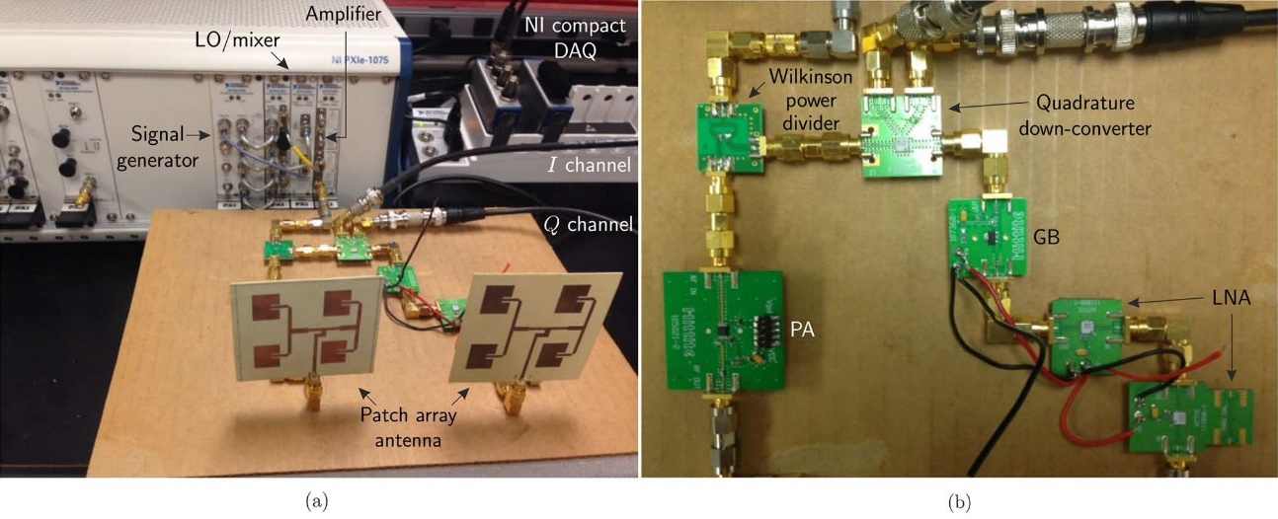

Fig. 2.9. Photograph of the developed LFMCW radar system prototype. (a) Complete view. (b) Detail.

The photograph of the constructed LFMCW radar system is depicted in Fig. 2.9. It consists of Tx, Rx, and signal-acquisition modules. A photograph of the experiment setup for vital-sign sensing from human target is depicted in Fig.2.10.

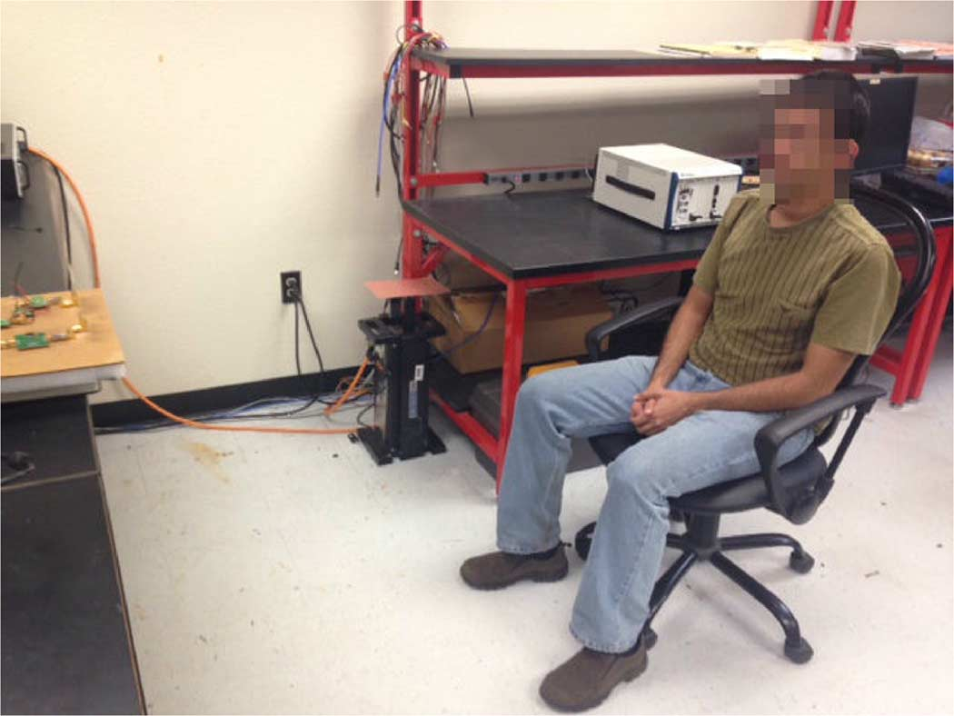

Fig. 2.10. Photograph of the real experimental setup of the human vital-sign

tracking test

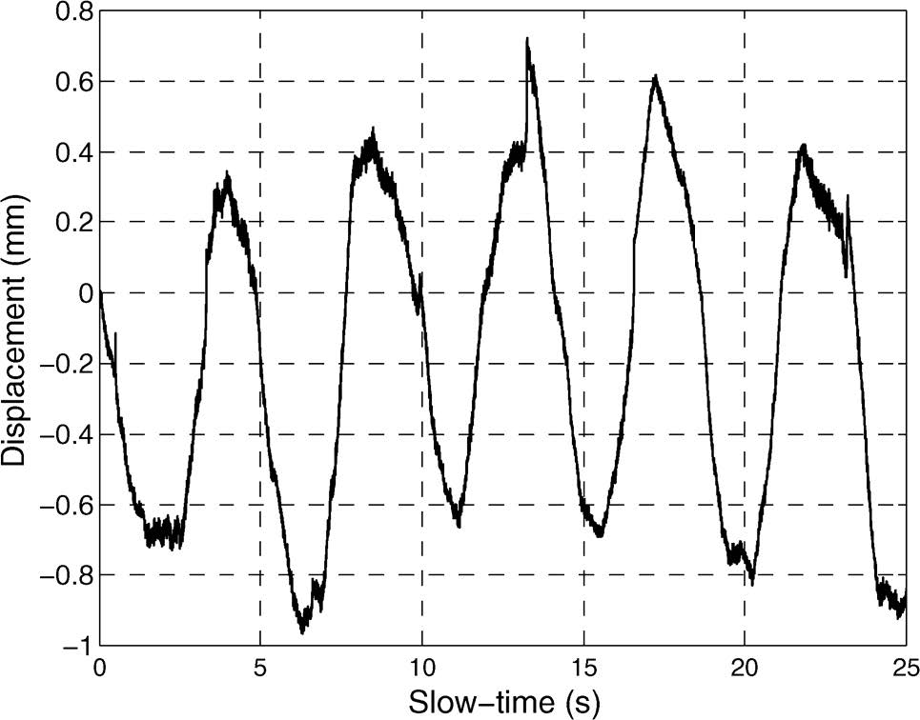

Fig. 2.11. Detected human respiration pattern

Fig.2.11 plots the measured human respiration detection result. The respiration rate of the subject was about 13 cycles/min.

Several hybrid radar systems that integrates the FMCW mode and interferometry mode have been published [2][3]. The FMCW mode is responsible for absolute range detection and the interferometry mode takes care of weak physiological movement monitoring.

A PCB realization of a K-band portable FMCW radar with beamforming array is presented [4]. It demonstrated an alternative approach to achieve portable and low-cost beamforming array radar systems with vector controllers and a six-port circuit. Range-gating and beamforming techniques allow the signal of interest to be isolated from surrounding clutter [5].

In addition, some companies such as Texas Instruments, Infineon, and Calterah have developed a series of FMCW radar products [6], and these products have greatly contributed to the development of vital sign monitoring using FMCW radars.

**Reference**

[1] G. Wang, J. Muñoz-Ferreras, C. Gu, C. Li and R. Gómez-García, "Application of Linear-Frequency-Modulated Continuous-Wave (LFMCW) Radars for Tracking of Vital Signs," in IEEE Transactions on Microwave Theory and Techniques, vol. 62, no. 6, pp. 1387-1399, June 2014, doi: 10.1109/TMTT.2014.2320464.

[2] Z. Peng et al., "A Portable FMCW Interferometry Radar With Programmable Low-IF Architecture for Localization, ISAR Imaging, and Vital Sign Tracking," in IEEE Transactions on Microwave Theory and Techniques, vol. 65, no. 4, pp. 1334-1344, April 2017, doi: 10.1109/TMTT.2016.2633352.

[3] G. Wang, C. Gu, T. Inoue and C. Li, "A Hybrid FMCW-Interferometry Radar for Indoor Precise Positioning and Versatile Life Activity Monitoring," in IEEE Transactions on Microwave Theory and Techniques, vol. 62, no. 11, pp. 2812-2822, Nov. 2014, doi: 10.1109/TMTT.2014.2358572.

[4] Z. Peng, L. Ran and C. Li, "A K-Band Portable FMCW Radar With Beamforming Array for Short-Range Localization and Vital-Doppler Targets Discrimination," in IEEE Transactions on Microwave Theory and Techniques, vol. 65, no. 9, pp. 3443-3452, Sept. 2017, doi: 10.1109/TMTT.2017.2662680.

[5] A. Ahmad, J. C. Roh, D. Wang and A. Dubey, "Vital signs monitoring of multiple people using a FMCW millimeter-wave sensor," 2018 IEEE Radar Conference (RadarConf18), Oklahoma City, OK, 2018, pp. 1450-1455, doi: 10.1109/RADAR.2018.8378778.

[6] A. Santra et al., "Short-range multi-mode continuous-wave radar for vital sign measurement and imaging," 2018 IEEE Radar Conference (RadarConf18), Oklahoma City, OK, 2018, pp. 0946-0950, doi: 10.1109/RADAR.2018.8378688.

[7] Boris Atayants; Viacheslav Davydochkin; Victor Ezerskiy; Valery Parshin; Sergey Smolskiy, "Precision FMCW Short-Range Radar for Industrial Applications," in Precision FMCW Short-Range Radar for Industrial Applications , Artech, 2014.

[8] Mervin Budge; Shawn German, "Basic Radar Analysis," in Basic Radar Analysis , Artech, 2015.

[9] Igor Komarov; Sergey Smolskiy, "Fundamentals of Short-Range FM Radar," in Fundamentals of Short-Range FM Radar , Artech, 2003.